

**Capstone Project Report**

**Report 4 – Software Design Document**

– Ho Chi Minh City, December 2025 –

**Table of Contents**

I. Record of Changes 3

II. Software Design Document 4

1. System Design 4

1.1 System Architecture Diagram 4

1.2 Component Diagram 5

2. Database Design 7

3. Detailed Design 15

3.1 Program & Course Management 15

3.1.1 Class Diagram 15

3.1.2 Sequence Diagram - Admin Creates Program 15

3.1.3 Sequence Diagram - Admin Creates Course 17

3.1.4 Sequence Diagram - Admin Adds Course To Program 18

3.2 Class Management & Enrollment 19

3.2.1 Class Diagram 19

3.2.2 Sequence Diagram - Trainee Enrolls to Class 19

3.2.3 Sequence Diagram - Admin Confirms Enrollment 21

3.3 Simulation Practice Management 22

3.3.1 Class Diagram 22

3.3.2 Sequence Diagram - Simulation Manager Creates Practice 22

3.3.3 Sequence Diagram - Trainees Attempt Practice 24

3.4 Final Exam Management 25

3.4.1 Class Diagram 25

3.4.2 Sequence Diagram - Instructor Configs Final Exam 25

3.5 Dashboard & Reports 27

3.5.1 Class Diagram 27

3.5.2 Sequence Diagram - Admin Views Dashboard 27

# I. Record of Changes

|  |  |  |  |
| --- | --- | --- | --- |
| Date | A* M, D | In charge | Change Description |
|  |  |  |  |
|  |  |  |  |
|  |  |  |  |
|  |  |  |  |
|  |  |  |  |
|  |  |  |  |
|  |  |  |  |
|  |  |  |  |
|  |  |  |  |
|  |  |  |  |
|  |  |  |  |
|  |  |  |  |
|  |  |  |  |

*A - Added M - Modified D - Deleted

# II. Software Design Document

## 1. System Design

### 1.1 System Architecture Diagram

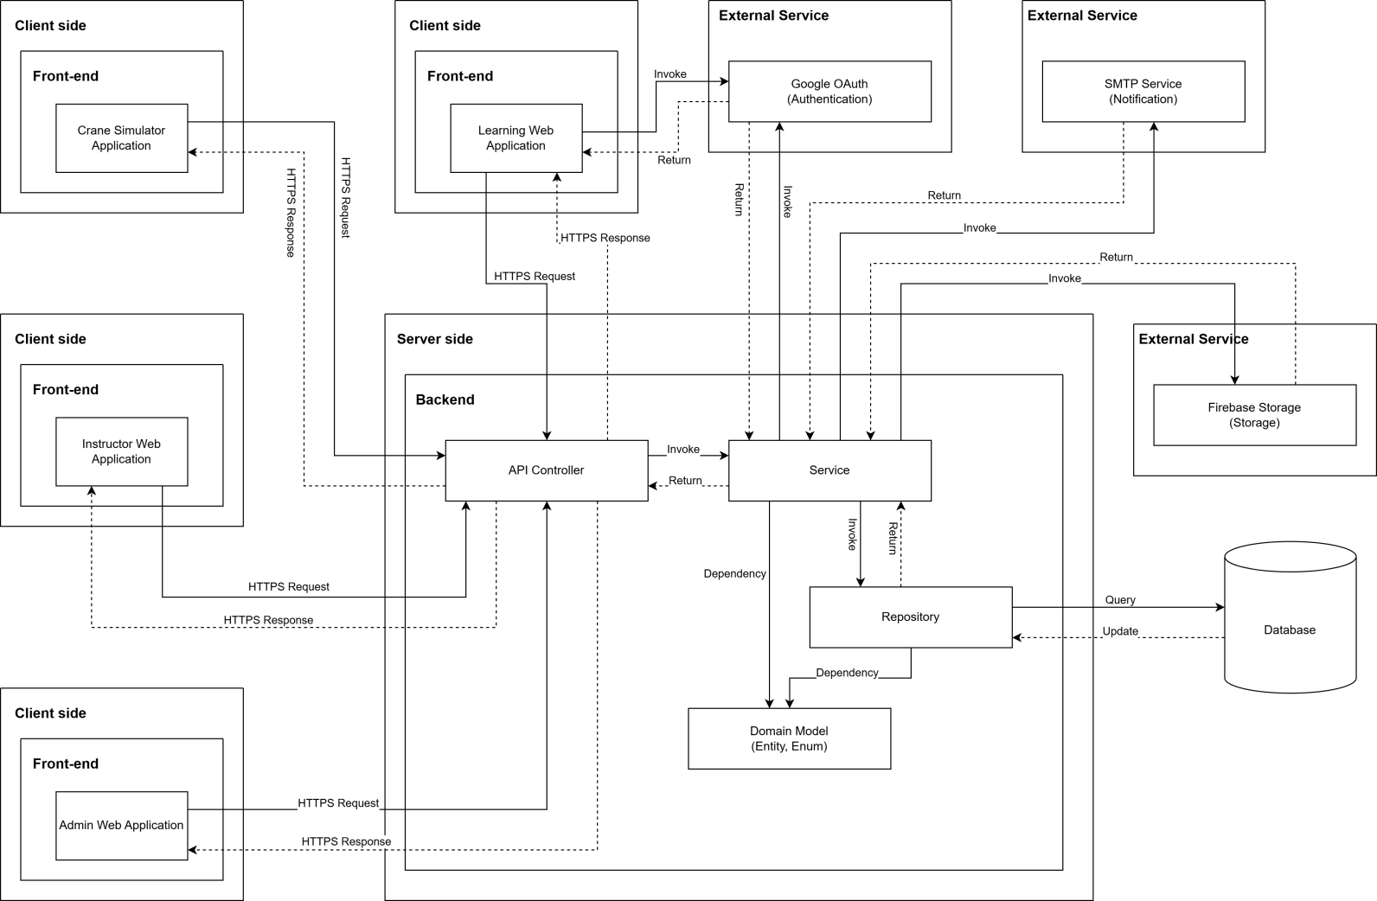

***System Architecture Diagram Descriptions***

|  |  |  |
| --- | --- | --- |
| **No** | **Name** | **Description** |
| 1 | Crane Simulator Application | Desktop application for practical crane operation training, communicates with backend via HTTPS to access training content and submit practice results |
| 2 | Learning Web Application | Web-based application for trainees to access learning materials, complete courses, take quizzes, and track their learning progress |
| 3 | Instructor Web Application | Web application for instructors to manage classes, create and grade quizzes, provide feedback, and monitor student progress |
| 4 | Admin Web Application | Web application for administrators to manage users, programs, courses, system settings, and overall platform administration |
| 5 | API Controller | RESTful API layer that receives HTTPS requests from client applications, routes them to appropriate services, and returns responses |
| 6 | Service | Business logic layer containing core application logic, processing business rules, orchestrating workflows, and coordinating between controllers and repositories |
| 7 | Repository | Data access layer that abstracts database operations, handles CRUD operations, and manages data persistence using Entity Framework or similar ORM |
| 8 | Domain Model (Entity, Enum) | Domain entities and enumerations representing the core business objects and data structures (Users, Courses, Classes, Quizzes, etc.) |
| 9 | Database | SQL Server database storing all system data including users, courses, enrollments, quiz attempts, practice results, and certificates |
| 10 | Google OAuth (Authentication) | External authentication service for user login using Google accounts, providing secure OAuth 2.0 authentication flow |
| 11 | SMTP Service (Notification) | External email service for sending notifications, alerts, password resets, and course-related communications to users |
| 12 | Firebase Storage (Storage) | Cloud storage service for storing and serving media files including course materials, videos, images, documents, and user-uploaded content |

### 1.2 Component Diagram

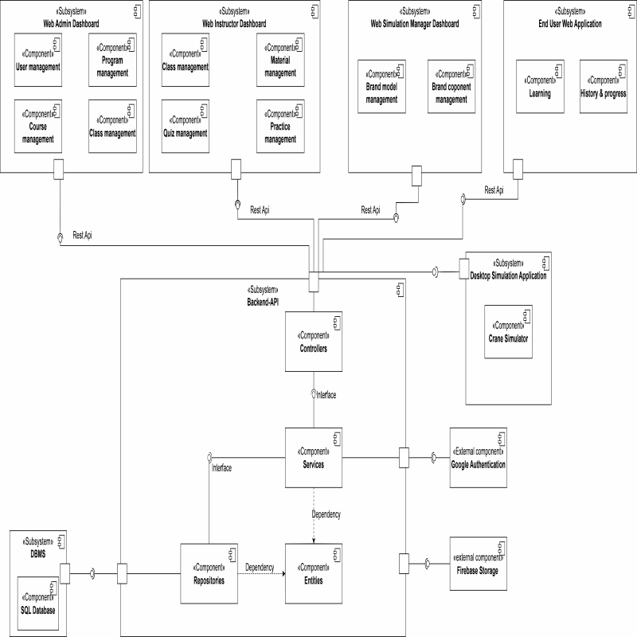

***Component Diagram Descriptions***

|  |  |  |
| --- | --- | --- |
| **No** | **Name** | **Description** |
| 1 | Web Admin Dashboard | Web administrative interface for Admin, including user management, program management, and course management features |
| 2 | User management | Component for managing users, handling account information, permissions, and user administration in the system |
| 3 | Program management | Component for managing training programs, organizing courses and curriculum |
| 4 | Course management | Component for managing courses, learning content, lectures, and materials |
| 5 | Web Instructor Dashboard | Web interface for instructors, including class management and quiz management |
| 6 | Class management | Component for managing classes, student lists, schedules, and attendance |
| 7 | Material management | Component for managing learning materials, lectures, videos, and attached files |
| 8 | Quiz management | Component for managing quizzes, questions, answers, and test results |
| 9 | Practice management | Component for managing practice exercises, assignments, and homework |
| 10 | Web Simulation Manager Dashboard | Simulation management interface, including brand model management and brand component management |
| 11 | Brand model management | Component for managing brand models in business simulation |
| 12 | Brand component management | Component for managing components and competitors in simulation |
| 13 | End User Web Application | Web application for end users (students), including learning features and history & progress tracking |
| 14 | Learning | Component handling the learning process, viewing lectures, and completing exercises for students |
| 15 | History & progress | Component tracking learning history and course completion progress for students |
| 16 | End User Desktop Application | Desktop application for end users, including practical training features |
| 17 | Practical Training | Component handling practical exercises on desktop application |
| 18 | Firebase Storage | Firebase file storage service for storing images, videos, documents, and attached files |
| 19 | Backend API | Backend API system handling business logic, including Controllers, Services, Repositories, and Entities |
| 20 | Controllers | Controller layer handling HTTP requests from clients, routing to corresponding services |
| 21 | Services | Business logic layer containing business rules and system processing logic |
| 22 | Repositories | Data access layer handling CRUD operations with the database |
| 23 | Entities | Layer defining data objects (data models) mapped to the database |
| 24 | Google Authentication | Component authenticating users through Google OAuth, supporting Google account login |
| 25 | DBMS | Database management system containing SQL Database storing all system data |
| 26 | SQL Database | SQL database (PostgreSQL/MySQL) storing user data, courses, exercises, and learning results |

## Database Design

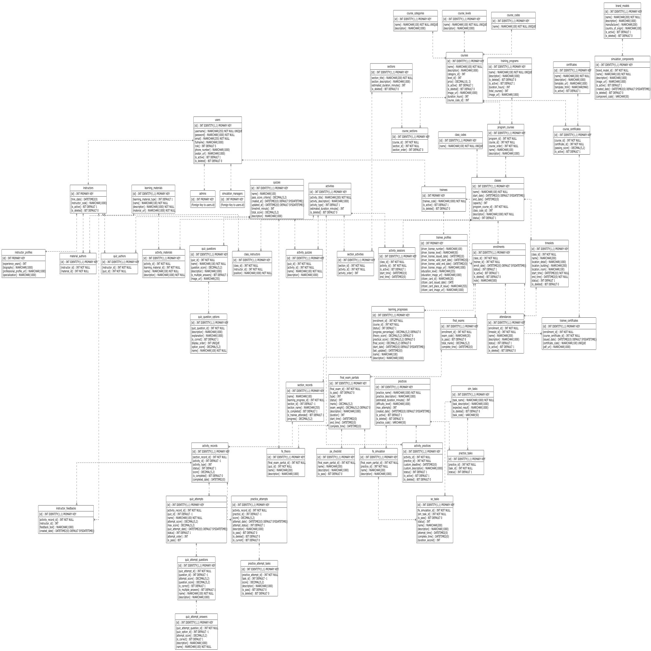

***Table Descriptions***

|  |  |  |
| --- | --- | --- |
| **No** | **Table** | **Description** |
| 1 | users | Stores the core account information for all system users including login credentials and contact info.  - Primary keys: id  - Foreign keys: None |
| 2 | admins | Stores specific information for users with the Admin role, linked to the main user record.  - Primary keys: id  - Foreign keys: id |
| 3 | simulation_managers | Stores specific information for Simulation Managers, linked to the main user record.  - Primary keys: id  - Foreign keys: id |
| 4 | instructors | Stores specific information for Instructors, including employment details.  - Primary keys: id  - Foreign keys: id |
| 5 | trainees | Stores specific information for Trainees/Learners.  - Primary keys: id  - Foreign keys: id |
| 6 | instructor_profiles | Contains detailed profile information for instructors such as experience and biography.  - Primary keys: id  - Foreign keys: id |
| 7 | trainee_profiles | Contains detailed profile information for trainees, including driver license and citizen card details.  - Primary keys: id  - Foreign keys: id |
| 8 | course_categories | Lookup table for defining different categories of courses.  - Primary keys: id  - Foreign keys: None |
| 9 | course_levels | Lookup table for defining the difficulty or progression levels of courses.  - Primary keys: id  - Foreign keys: None |
| 10 | course_codes | Lookup table for standardized course codes. - Primary keys: id - Foreign keys: None |
| 11 | courses | Stores the main course definitions including metadata like price and duration. - Primary keys: id  - Foreign keys: category_id, level_id, course_code_id |
| 12 | training_programs | Defines high-level training programs that aggregate multiple courses.  - Primary keys: id  - Foreign keys: None |
| 13 | program_courses | Junction table linking Courses to Training Programs, defining the order of courses within a program.  - Primary keys: id  - Foreign keys: program_id, course_id |
| 14 | sections | Defines content sections that organize activities within a course.  - Primary keys: Id  - Foreign keys: None |
| 15 | course_sections | Junction table mapping sections to courses and defining their sequence.  - Primary keys: Id  - Foreign keys: course_id, section_id |
| 16 | activities | Stores individual learning activities (e.g., lessons, quizzes) that belong to sections. - Primary keys: id - Foreign keys: None |
| 17 | learning_materials | Stores information about study materials like documents or videos.  - Primary keys: id  - Foreign keys: None |
| 18 | material_authors | Links learning materials to the instructors who authored them.  - Primary keys: id  - Foreign keys: instructor_id, material_id |
| 19 | section_activities | Junction table mapping activities to specific sections and defining their order.  - Primary keys: id - Foreign keys: section_id, activity_id |
| 20 | activity_materials | Links learning materials to specific activities.  - Primary keys: id  - Foreign keys: activity_id, learning_material_id |
| 21 | quizzes | Defines quiz assessments including time limits and passing criteria.  - Primary keys: id  - Foreign keys: None |
| 22 | quiz_authors | Links quizzes to the instructors who created them.  - Primary keys: id  - Foreign keys: instructor_id, quiz_id |
| 23 | quiz_questions | Stores questions belonging to a specific quiz.  - Primary keys: id  - Foreign keys: quiz_id |
| 24 | quiz_question_options | Stores the possible answer options for a quiz question.  - Primary keys: id  - Foreign keys: quiz_question_id |
| 25 | activity_quizzes | Junction table linking a Quiz to an Activity entity.  - Primary keys: id  - Foreign keys: quiz_id, activity_id |
| 26 | practices | Defines practical training exercises or simulation scenarios.  - Primary keys: id  - Foreign keys: None |
| 27 | sim_tasks | Defines specific tasks or steps required within a simulation.  - Primary keys: id  - Foreign keys: None |
| 28 | practice_tasks | Junction table linking simulation tasks to a practice scenario.  - Primary keys: id  - Foreign keys: practice_id, task_id |
| 29 | activity_practices | Junction table linking a Practice to an Activity entity.  - Primary keys: id  - Foreign keys: activity_id, practice_id |
| 30 | brand_models | Specific brand models of equipment (cranes) used in simulations.  - Primary keys: id  - Foreign keys: None |
| 31 | simulation_components | Stores detailed components associated with specific brand models.  - Primary keys: id  - Foreign keys: brand_model_id |
| 32 | class_codes | Lookup table for standardized class codes.  - Primary keys: id  - Foreign keys: None |
| 33 | classes | Represents a scheduled instance of a course (program course) with start/end dates.  - Primary keys: id  - Foreign keys: program_course_id, class_code_id |
| 34 | class_instructors | Assigns instructors to specific classes with a designated position.  - Primary keys: id  - Foreign keys: class_id, instructor_id |
| 35 | enrollments | Records the registration of a trainee in a specific class.  - Primary keys: id  - Foreign keys: class_id, trainee_id |
| 36 | timeslots | Defines specific scheduling slots (date/time/location) for a class.  - Primary keys: id  - Foreign keys: class_id |
| 37 | attendances | Tracks trainee attendance for specific timeslots.  - Primary keys: id  - Foreign keys: enrollment_id, timeslot_id |
| 38 | activity_sessions | Schedules specific activities within a class timeframe.  - Primary keys: id  - Foreign keys: class_id, activity_id |
| 39 | final_exams | Stores the overall record of a final exam for an enrollment.  - Primary keys: id  - Foreign keys: enrollment_id |
| 40 | final_exam_partials | Stores specific parts (theory/practical) of a final exam.  - Primary keys: id  - Foreign keys: final_exam_id |
| 41 | pe_checklist | Stores checklist items for grading practical final exams.  - Primary keys: id  - Foreign keys: final_exam_partial_id |
| 42 | fe_theory | Links a final exam partial to a specific theory quiz.  - Primary keys: id  - Foreign keys: final_exam_partial_id, quiz_id |
| 43 | fe_simulation | Links a final exam partial to a specific simulation practice.  - Primary keys: id  - Foreign keys: final_exam_partial_id, practice_id |
| 44 | se_tasks | Tracks the result of specific tasks within a simulation final exam.  - Primary keys: id  - Foreign keys: fe_simulation_id, sim_task_id |
| 45 | certificates | Defines certificate templates available in the system.  - Primary keys: id  - Foreign keys: None |
| 46 | course_certificates | Links certificates to courses, defining passing requirements.  - Primary keys: id  - Foreign keys: course_id, certificate_id |
| 47 | trainee_certificates | Records certificates issued to trainees upon course completion.  - Primary keys: id  - Foreign keys: enrollment_id, course_certificate_id |
| 48 | learning_progresses | Tracks the overall progress of a trainee within an enrollment.  - Primary keys: id  - Foreign keys: enrollment_id |
| 49 | section_records | Tracks a trainee's completion status for specific course sections.  - Primary keys: id  - Foreign keys: learning_progress_id |
| 50 | activity_records | Tracks the detailed status and score of a trainee for specific activities.  - Primary keys: id  - Foreign keys: section_record_id |
| 51 | instructor_feedbacks | Stores feedback provided by instructors on specific activity records.  - Primary keys: id  - Foreign keys: activity_record_id, instructor_id |
| 52 | practice_attempts | Records a specific attempt by a trainee to complete a practice activity.  - Primary keys: id  - Foreign keys: activity_record_id |
| 53 | practice_attempt_tasks | Records the result of individual tasks within a practice attempt.  - Primary keys: id  - Foreign keys: practice_attempt_id |
| 54 | quiz_attempts | Records a specific attempt by a trainee to complete a quiz.  - Primary keys: id  - Foreign keys: activity_record_id |
| 55 | quiz_attempt_questions | Records the trainee's answer/score for a specific question in a quiz attempt.  - Primary keys: id  - Foreign keys: quiz_attempt_id |
| 56 | quiz_attempt_answers | Records the specific option selected by a trainee for a question.  - Primary keys: id  - Foreign keys: quiz_attempt_question_id |

## 3. Detailed Design

### 3.1 Program & Course Management

#### 3.1.1 Class Diagram



#### 3.1.2 Sequence Diagram - Admin Creates Program

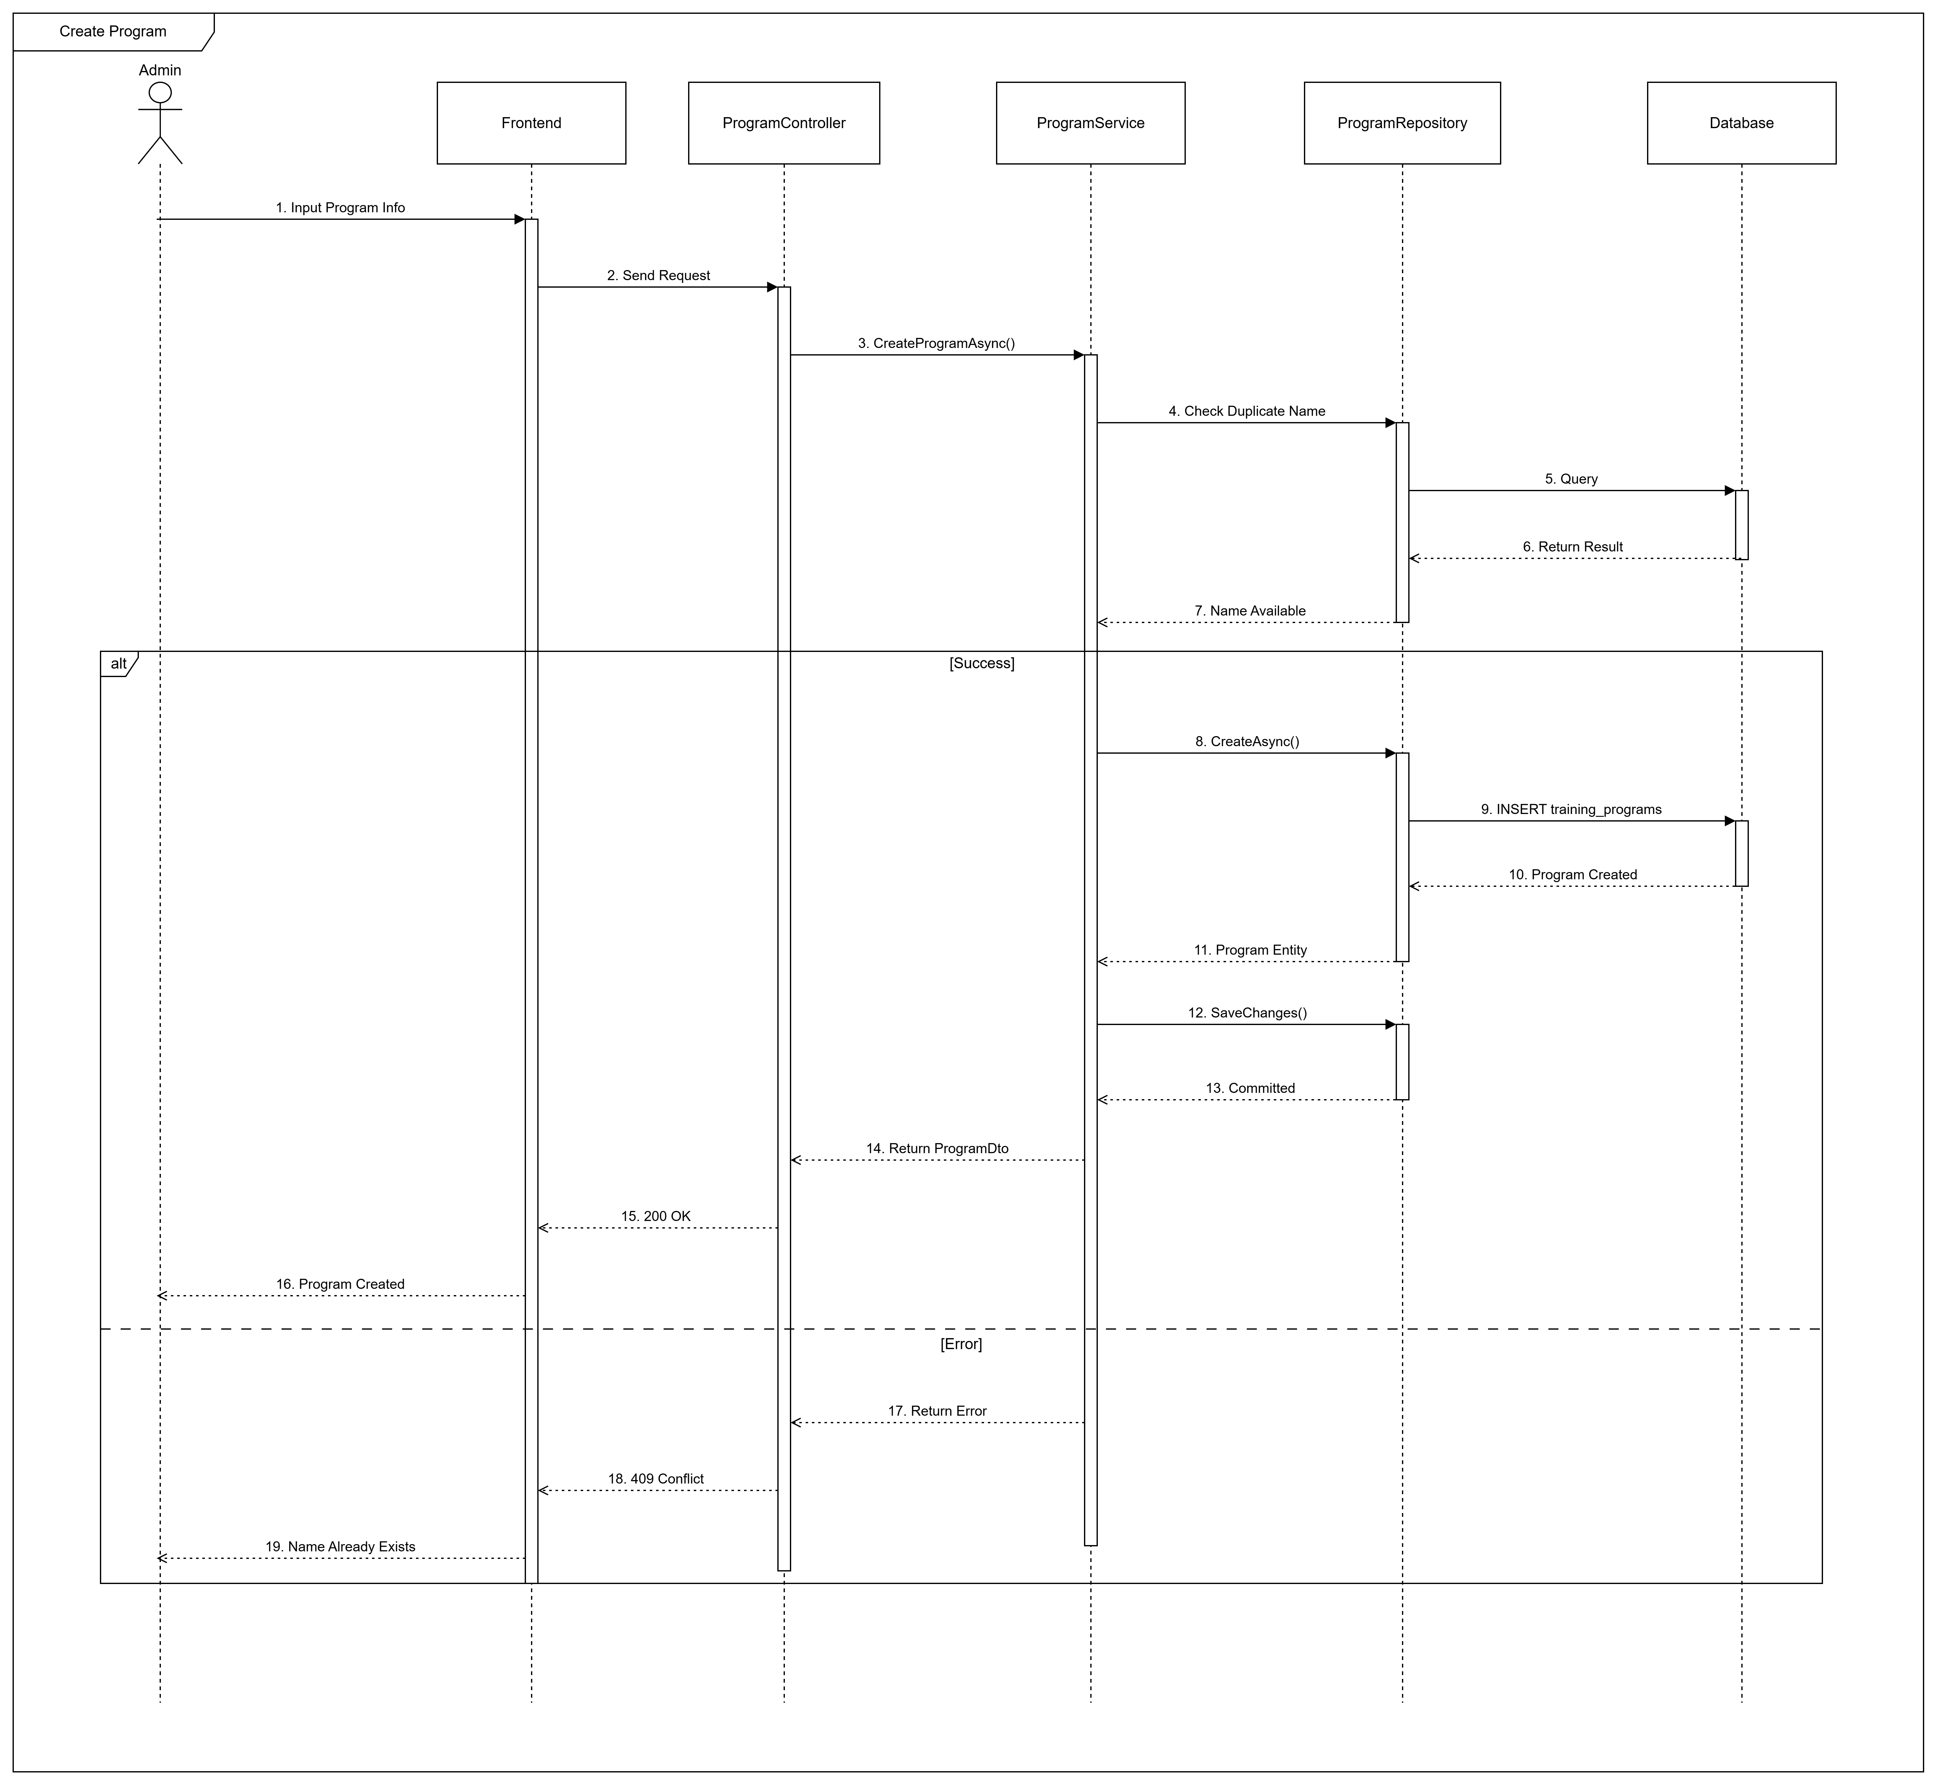

#### 3.1.3 Sequence Diagram - Admin Creates Course



#### 3.1.4 Sequence Diagram - Admin Adds Course To Program



### 3.2 Class Management & Enrollment

#### 3.2.1 Class Diagram



#### 3.2.2 Sequence Diagram - Trainee Enrolls to Class



#### 3.2.3 Sequence Diagram - Admin Confirms Enrollment



### 3.3 Simulation Practice Management

#### 3.3.1 Class Diagram

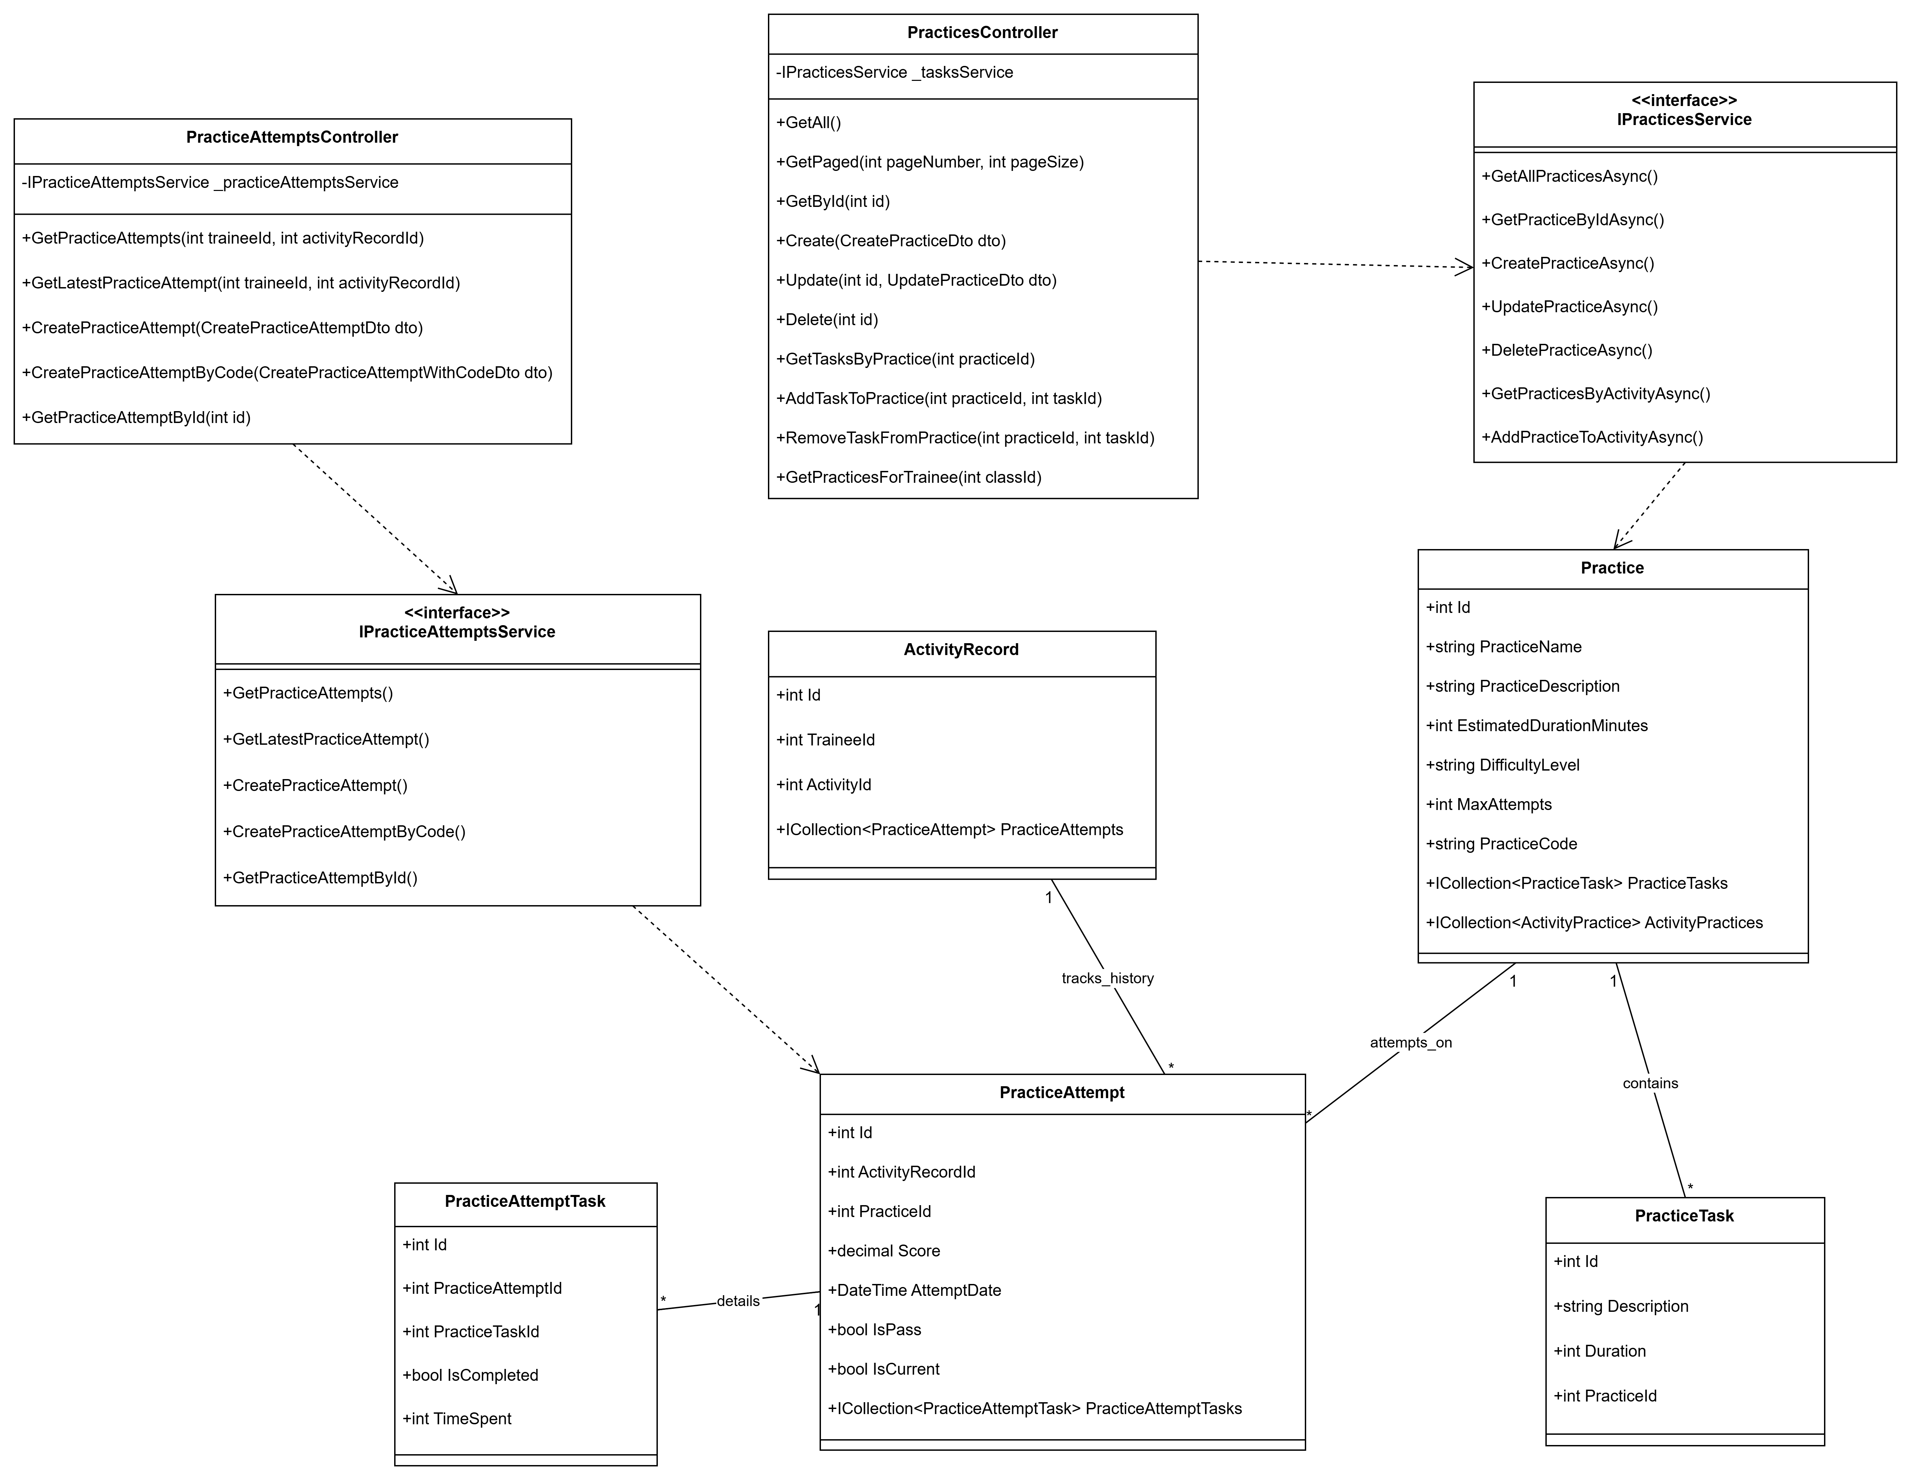

#### 3.3.2 Sequence Diagram - Simulation Manager Creates Practice



#### 3.3.3 Sequence Diagram - Trainees Attempt Practice

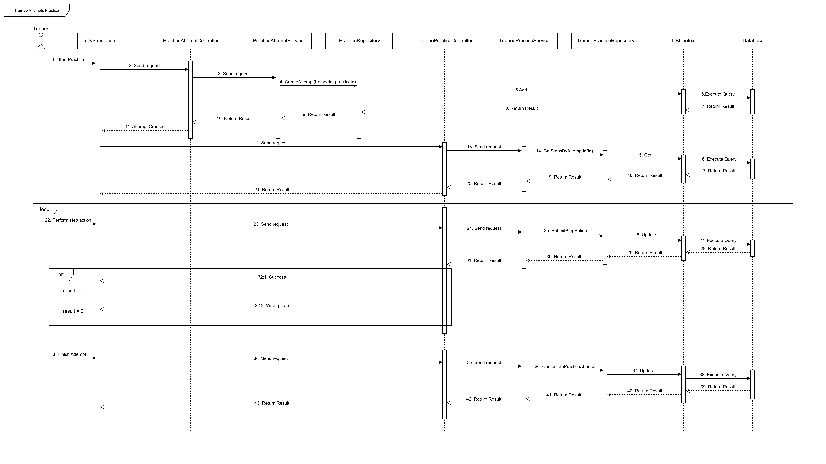

### 3.4 Final Exam Management

#### 3.4.1 Class Diagram

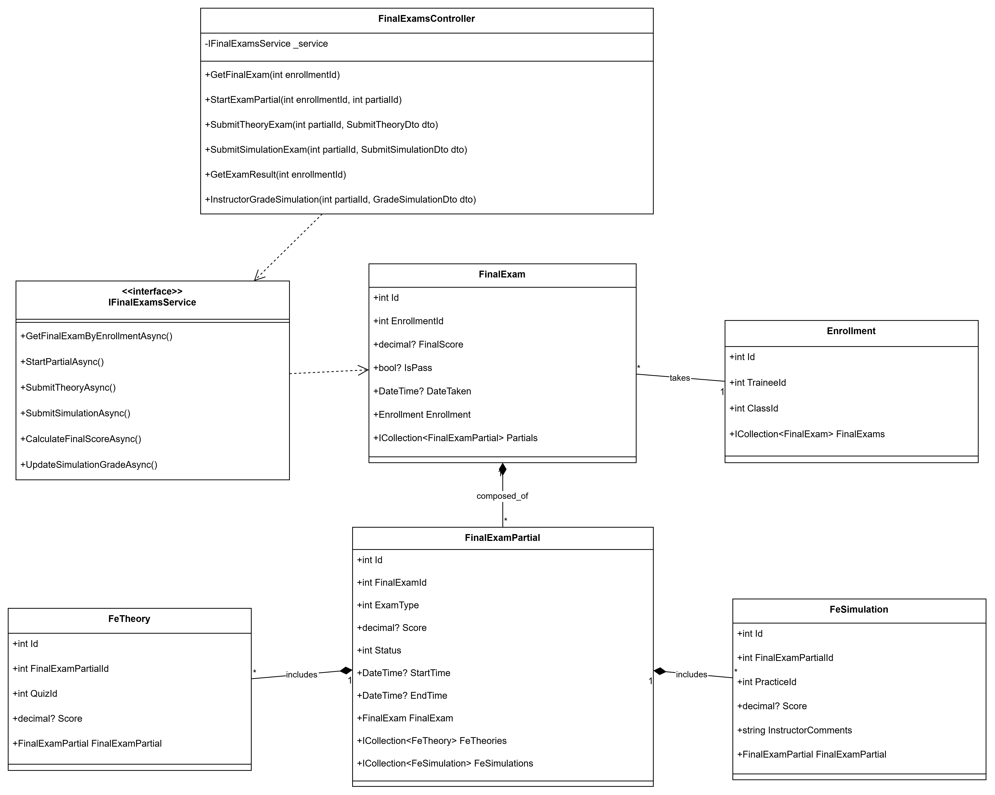

#### 3.4.2 Sequence Diagram - Instructor Configs Final Exam



### 3.5 Dashboard & Reports

#### 3.5.1 Class Diagram

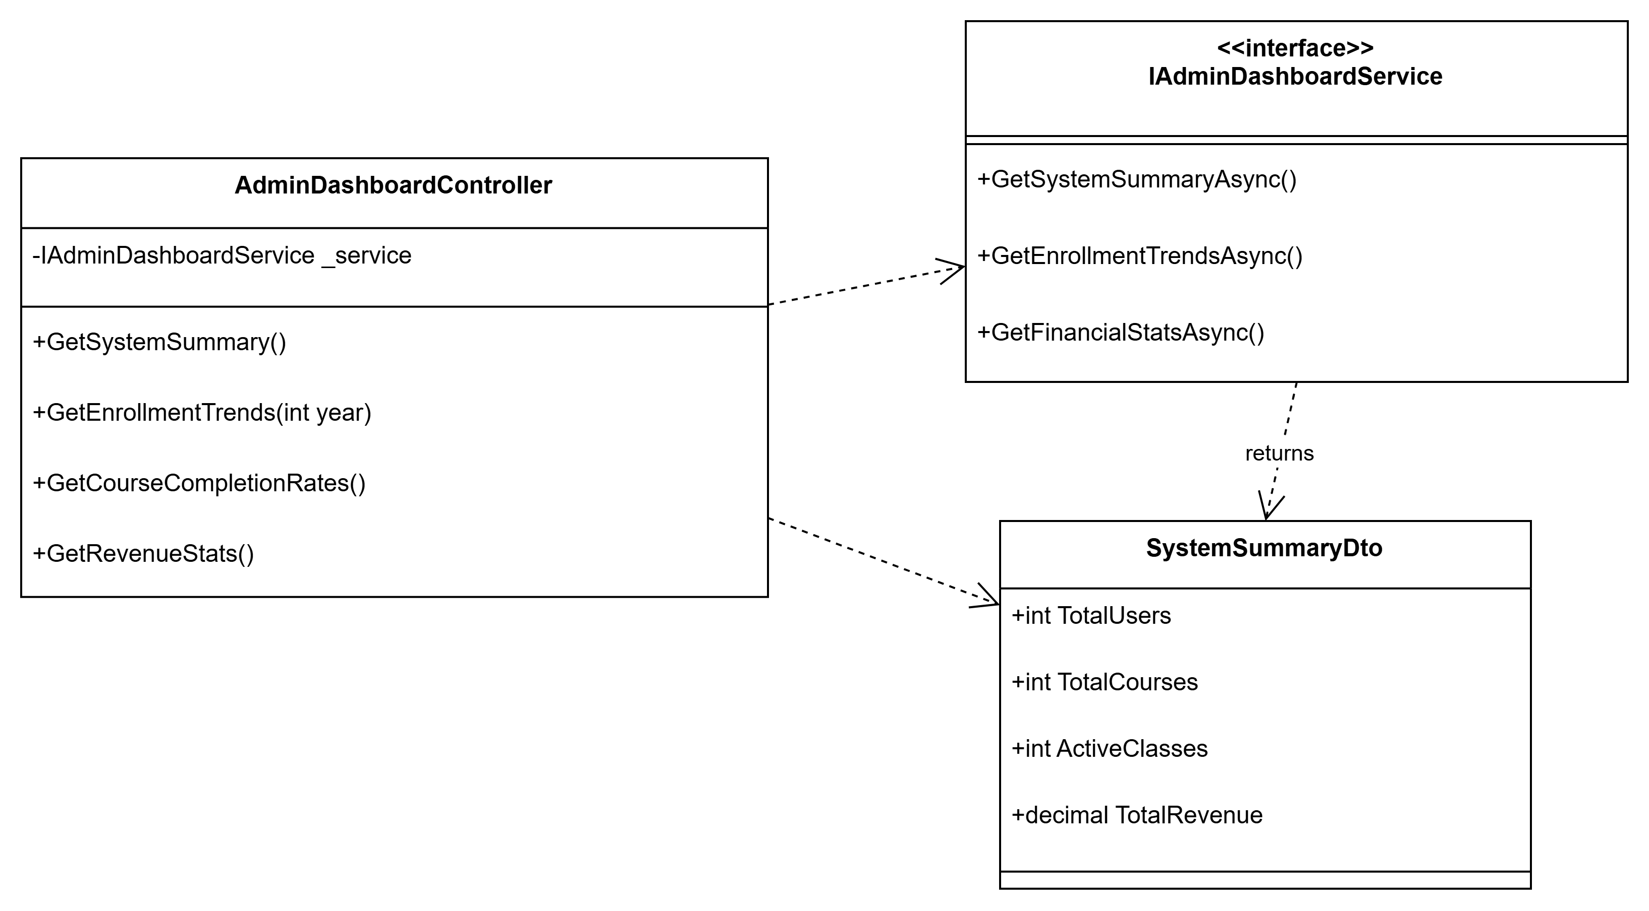

#### 3.5.2 Sequence Diagram - Admin Views Dashboard

